**Lab 4-3: Linking Two Tables Using VLOOKUP for Relational Data in Excel**

**Master the Data:** Open the Excel file for Lab 4-3.

**Step 1:** Add a new column to the Sales_Transactions table for the Product_Description associated with every Product_Code listed in the transactions table.

Navigate to the Sales_Transactions spreadsheet. Add a new column to the right of the Product_Sale_Price named Product_Description (cell H1). In cell H2, we will create a VLOOKUP Function.

**Step 2:** Because the ranges of data are not only formatted as tables, but also named properly, the VLOOKUP function should be relatively easy to follow: =VLOOKUP([@[Product_Code]],Products,2,FALSE). Click Enter; the formula should copy all the way down, once again exhibiting the benefits of working with Excel tables instead of ranges.

**Step 3:**

1. Create a column titled Customer_St in the Sales_Transactions table. Use VLOOKUP to match the Customer_ID from the Sales_Transaction table to the Customer_ID in the Customers table and pull in the data from the column containing Customer_St.
2. Create a column titled Customer_City. Use VLOOKUP to match the Customer_ID from the Sales_Transactions table to the Customer_ID in the Customers table and pull in the data from the column containing Customer_City.

**Step 4:** One of the benefits of using VLOOKUP functions to add descriptive attributes to the transactions table is to analyze the sales data more thoroughly using PivotTables. Create a PivotTable from the new Sales_Transactions table. You may need to click Refresh from the Analyze tab on the ribbon to see the new attributes.

**Lab 4-4 Linking Tables in Excel using the Internal Data Model**

**Master the Data:** Open Excel File Lab 4-4 Data.xlsx.

In Lab 4-3, you created VLOOKUPs to bring descriptive attributes about the products and customers into the Sales_Transactions table. An option is to build the relationships in Excel; this option is preferable if you want to be able to access all the attributes in any of the three tables.

**Step 1:** From the Data tab in the ribbon, click Relationships. In the window that pops up, click New.

The first relationship is between the Sales_Transactions table and the Products table.

* Select Sales_Transactions as the first table and Product_Code as the foreign key.
* Then, select Products as the related table and Product_Code as the primary key.
* Click OK to enforce the relationship (as shown in Exhibit 4.38).

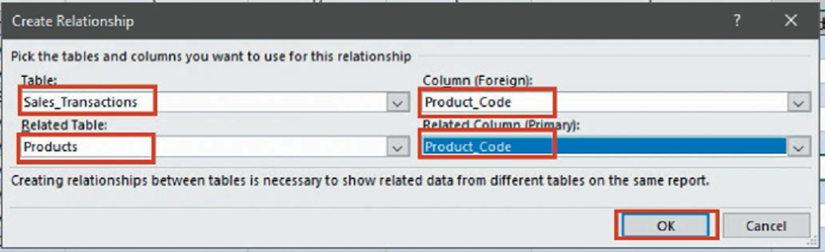

EXHIBIT 4.38

Click New… again to build the relationship between Sales_Transactions and Customers. Follow similar steps as above, except this time relate Customer_ID to Customer_ID, and then click close in the Manage Relationships window.

While it doesn’t appear that anything special has occurred between the tables in Excel, once we create a pivottable, we will see a difference.

**Step 2:** From any of the tables, create a pivottable. In the box that pops up, make sure to place a check mark next to Add this Data to the Data Model, then click OK.

In the PivotTable field list, change your view to All, as shown in Exhibit 4.40. This will adjust the field list from only showing the fields from the active table to showing the fields from all three tables.

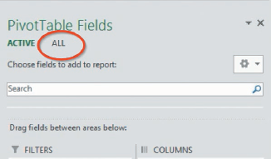

EXHIBIT 4.40

Step 3: Expand the Products table, and place a check mark next to Product_Description. Next, expand the Sales_Transactions table, and place a check mark next to Sales_Order_Quantity_Sold. Then expand the Customers table, and place a check mark next to Customer_St.

With these three fields in the pivottable, you have circumvented the need to use VLOOKUP to add the descriptive attributes to the Sales_Transactions table, and you can pivot and analyze data from all three tables in the Excel workbook together.